Angular Introduction

## Agenda:

1. Identify the Angular importance
2. Installing the Angular
3. First Application of Angular

Angular is an open-source front end framework developed by Google for creating Dynamic, modern web apps. This was introduced in the year of 2009. Angular 5 is introduced in the year of 2017 where this version has a lot of new approaches in front end web development.

Angular helps build interactive and dynamic web page applications(SPAs) with its compelling features including templates, two-way bindings, RESTful API handling, AJAX handling.

Angular applications are built using TypeScript Language, a superscript for javascript.

Angular framework is a embedded with MVC(Model, View and Controller) architecture

Software Architecture:

1. 1-Tier Architecture
2. 2-Tier Architecture
3. 3-Tier Architecture
4. n-Tier architecture
5. MVC Architecture
6. MVVC Architecture

## 3-Tier architecture:

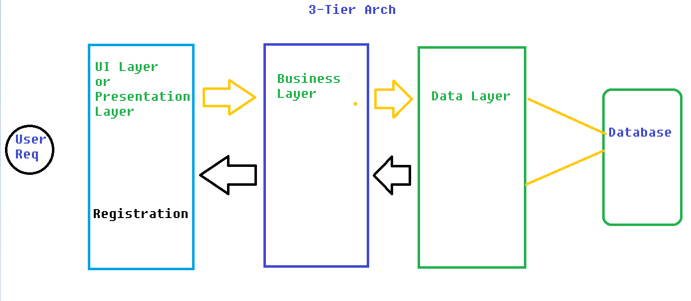

Presentation Layer or UI Layer : This is for designing the front end page or user is able to interact with it.

Business Layer:: Responsible for having business logic

Data Layer : Middle Layer between business layer and database.

## MVC architecture:

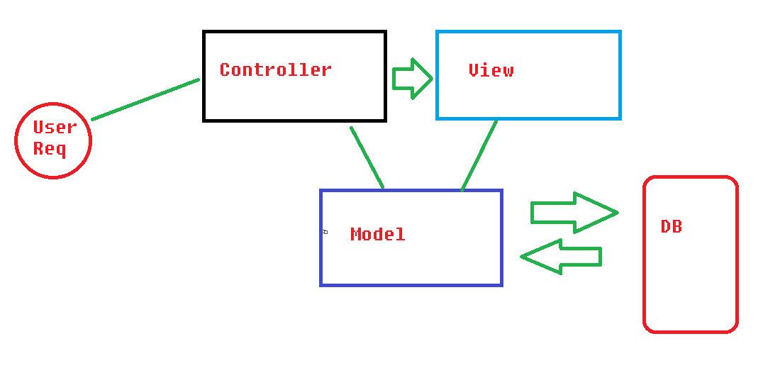

## Creating the First Application of Angular:

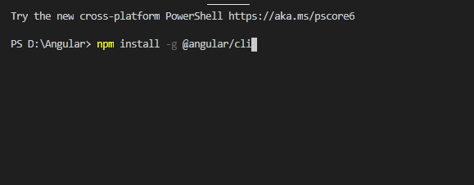

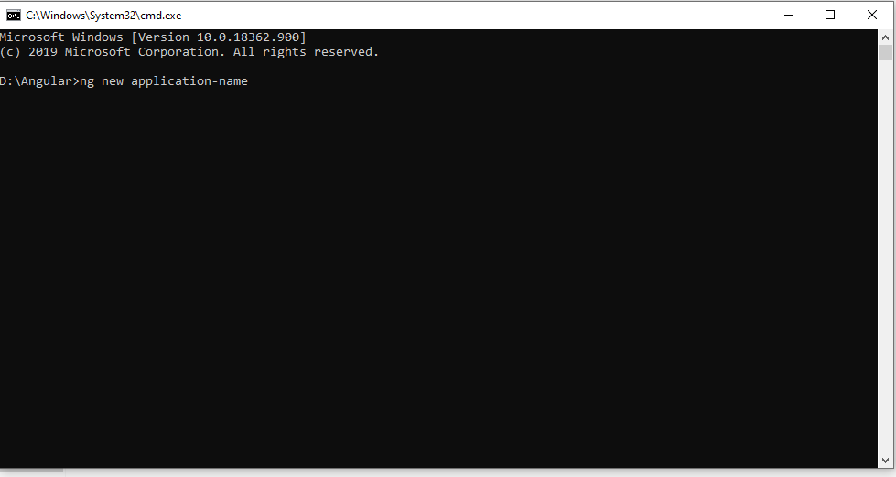

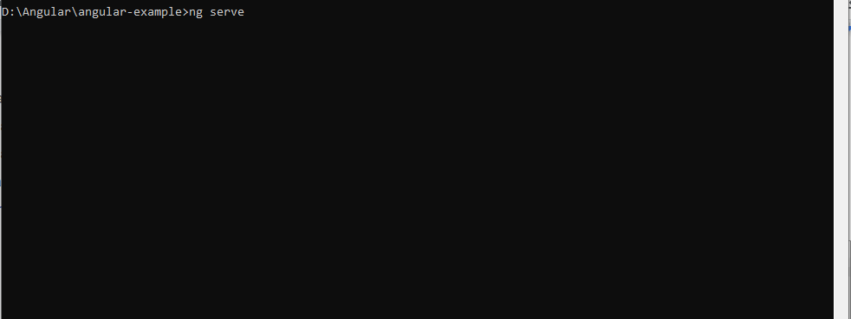

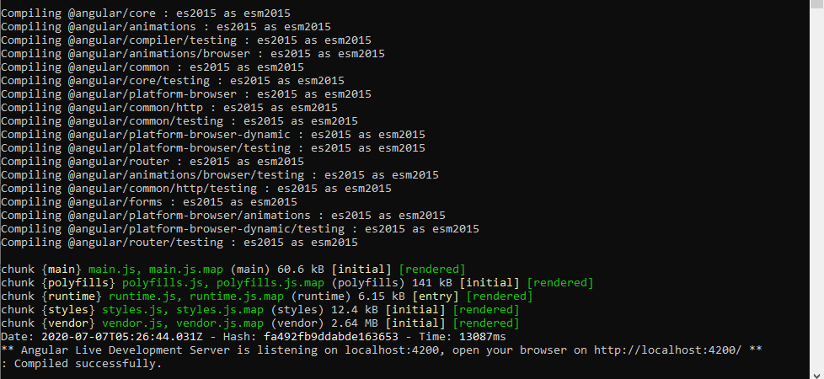

You go to Browser and run the port number 4200

Localhost:4200